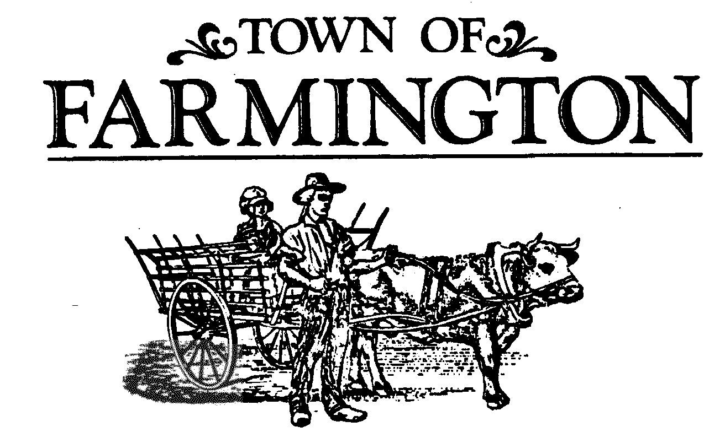

***Planning Board Meeting Agenda***

**July 16, 2025,**

**Meeting 7:00 p.m.**

**THIS MEETING WILL BE HELD IN THE MAIN MEETING ROOM, AT THE TOWN HALL, 1000 COUNTY ROAD 8, FARMINGTON, NEW YORK 14425. THOSE NOT WISHING TO ATTEND MAY PARTICIPATE VIRTUALLY IN THE MEETING BEING CONDUCTED SIMULTANEOUSLY AT THAT TIME ON-LINE, OR OVER THE PHONE. Join the meeting by clicking the following link:**

<https://zoom.us/j/93105325588?pwd=aGlsSkVySklVdTVldnBtWjNJbnlhZz09>

Meeting ID: 931 0532 5588

Passcode: 356169

One tap mobile

+16465588656,,93105325588#,,,,*356169# US (New York)

Dial by your location

+1 646 558 8656 US (New York)

Find your local number: <https://zoom.us/u/adnn0foxAt>

1. **OPEN MEETING** – Chairperson introduces members and Town staff present, identifies the emergency exits and informs that this meeting is to be conducted in accordance with the adopted 2025 Planning Board Rules of Procedure.

2. **APPROVAL OF** – **July 2, 2025, MEETING MINUTES.**

3. **LEGAL NOTICES PUBLISHED (0)** – Chairperson attests to no legal notices being published for tonight’s meeting.

4. **ORDER OF BUSINESS** -

1. **CONTINUED PUBLIC HEARINGS (0):**
2. **NEW PUBLIC HEARINGS (0):**
3. **PUBLIC MEETING ACTION ITEMS (5):**

1. **PB#2025-0603 Nick Lowry & Phyllis Caves, 4341 Cream Ridge Road, Macedon, N.Y. 14502.**

**Preliminary Site Plan Approval, Lot #2 Lowry Subdivision, single- family dwelling and related site improvements to be located along the west side of Ellsworth Road.**

2. **PB#2025-0701 Auto Outlets USA, 6162 State Route 96, Farmington, N.Y. 14425.**

**Final Site Plan Amendment, to construct a 1,980 square foot maintenance building addition and related site improvements. Findings and determination whether to accept the application for a public meeting.**

3. **PB#2025-0702 Donald Cheney/Cheney Law Firm, PLLC, 336 North Main Street, Canandaigua, N.Y. 14424.**

**Special Use Permit, to use an existing building located at 1118 County Road 8 for pet grooming business and related site improvements. Findings and determination whether to accept the application for a public meeting.**

4. **PB#2025-0703 Krossber Enterprises, LLC, 5984 State Route 96, Farmington, N.Y. 14425.**

**Preliminary Site Plan Approval, for the construction of a new office/retail building to be located on property at 5974 State Route 96 and combined with the existing buildings located at 5984 State Route 96. Findings and determination whether to accept the application for a public meeting.**

5. **PB#2025-0704 Laura Donaldson, Bridges for Brain Injury, 5760 Duke of Gloucester Way, Farmington, N.Y. 14425**

**Preliminary Site Plan Approval for the construction of a 16,000 square foot Day Programming Building, an 11,400 square foot Wildlife Education Building with adjacent outdoor wildlife area, as well as site related improvements, on the property at 1111 County Road 8, Farmington, NY 14425.** **Findings and determination whether to accept the application for a public meeting.**

### 5. OTHER BOARD ACTIONS (0):

6. **OPEN DISCUSSIONS:**

**Reports:** Director of Development

Code Enforcement Officer

Code Enforcement/Zoning Officer

Highway/Parks Superintendent

Town Engineer

Environmental Conservation Board

Farmington Fire Department

Planning Board Members

Planning Board Chairperson

7. **PUBLIC COMMENTS:**

8. **ADJOURNMENT OF MEETING**

**Next Meeting Date: Wednesday, August 6, 2025.**